Current_location:

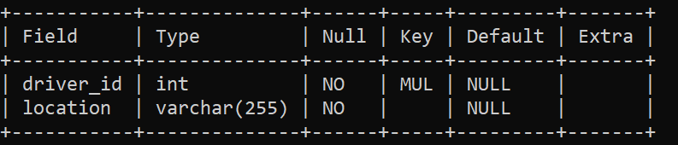

Drivers

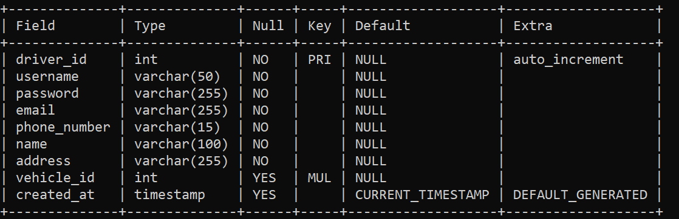

Fare_ref

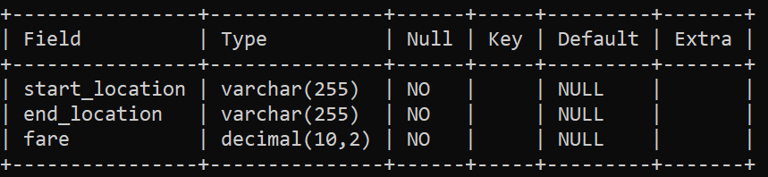

Payments

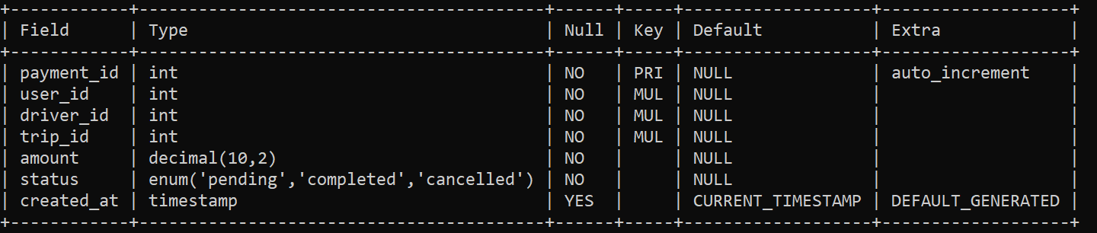

Ratings

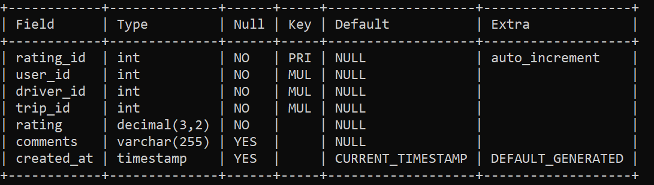

Trips

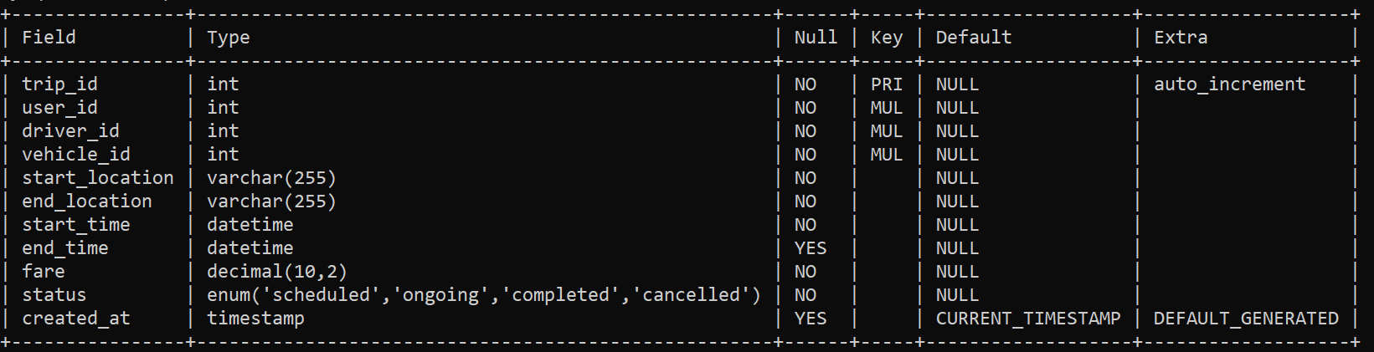

Users

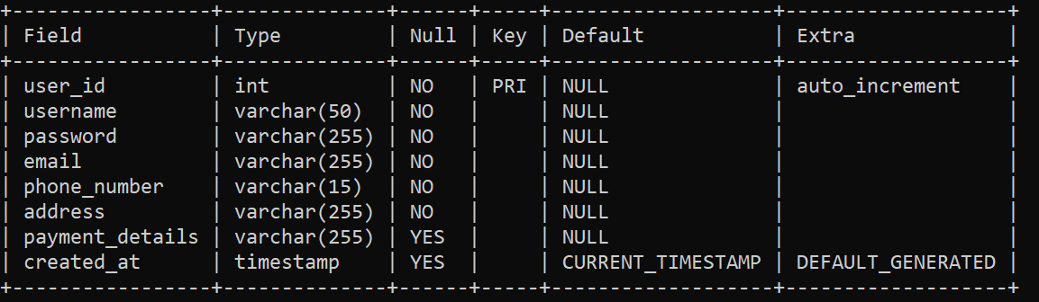

Vehicles

